**Flutter**

Pramod S Hiremath

1NT19IS411

Main.dart:

import 'package:flutter/material.dart';

void main() {

runApp(MaterialApp(

home: Scaffold(

appBar: AppBar(

title: Text("First App"),

),

body: Center(

child: Text("This is first App",

style: TextStyle(

fontSize : 40.0 ,

fontStyle : FontStyle . italic ,

fontWeight : FontWeight . bold ,

),

),

),

),

),

);

}

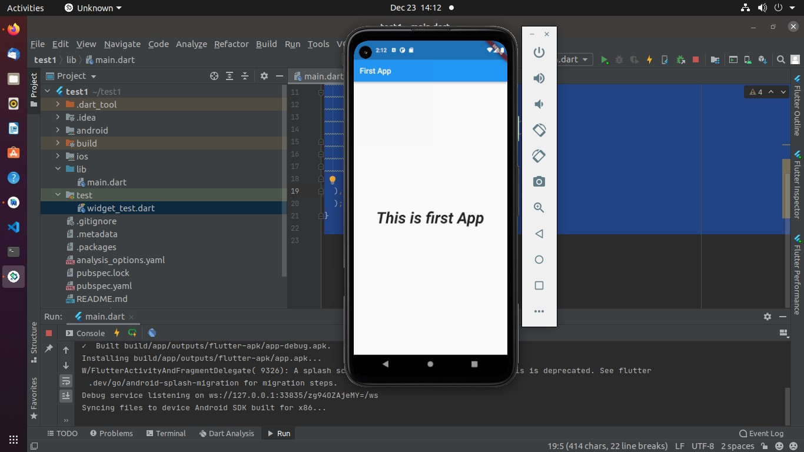

SafeArea

import 'package:flutter/material.dart'; void main() {

runApp(MaterialApp(

home: SafeArea(

child: Text(

'Without SafeArea',

textAlign: TextAlign.center,

style: TextStyle(

fontSize: 40,

fontWeight: FontWeight.w800,

color: Colors.deepOrangeAccent,

),

),

),

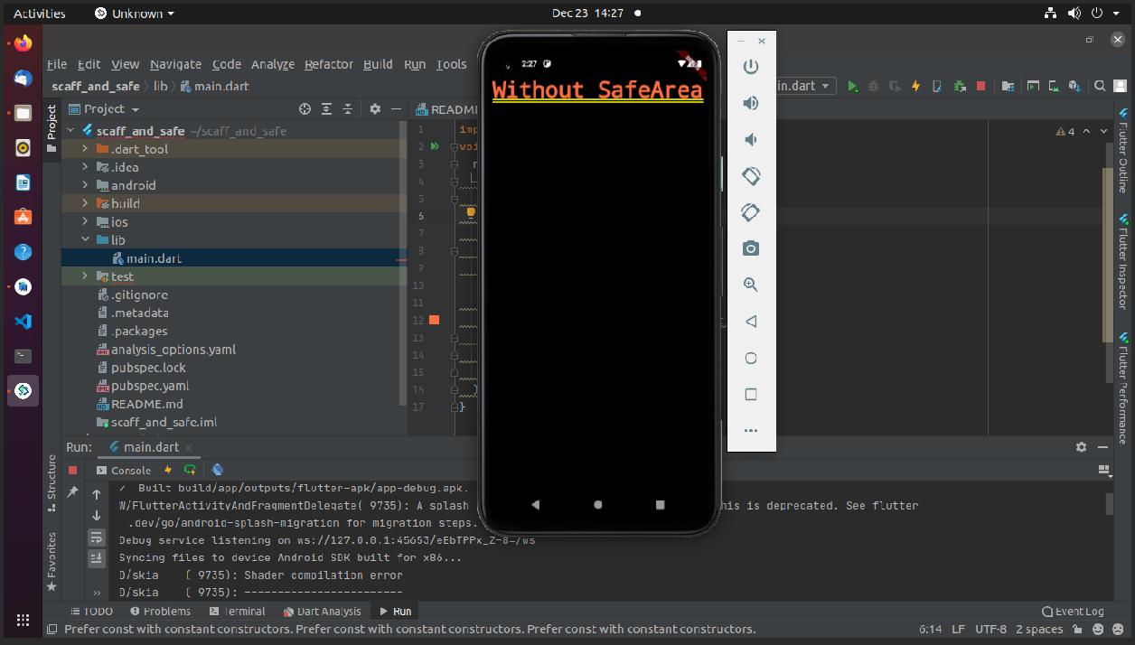}

Row

import 'package:flutter/material.dart'; void main() {

runApp(MaterialApp(

home: RowApp(

),

),

);

}

class RowApp extends StatelessWidget {

const RowApp({Key? key}) : super(key: key);

@override

Widget build(BuildContext context) {

return Scaffold(

appBar: AppBar(

title: Text(

"Row"

),

),

body: Row(

mainAxisAlignment: MainAxisAlignment.spaceEvenly,

crossAxisAlignment: CrossAxisAlignment.start,

children: [

}

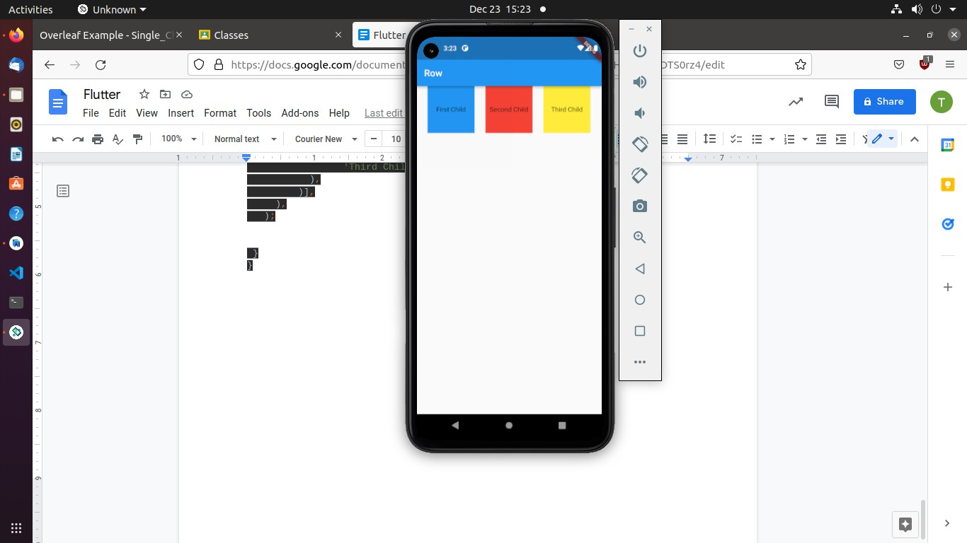

body: Row(

mainAxisAlignment: MainAxisAlignment.spaceEvenly,

crossAxisAlignment: CrossAxisAlignment.center,

children: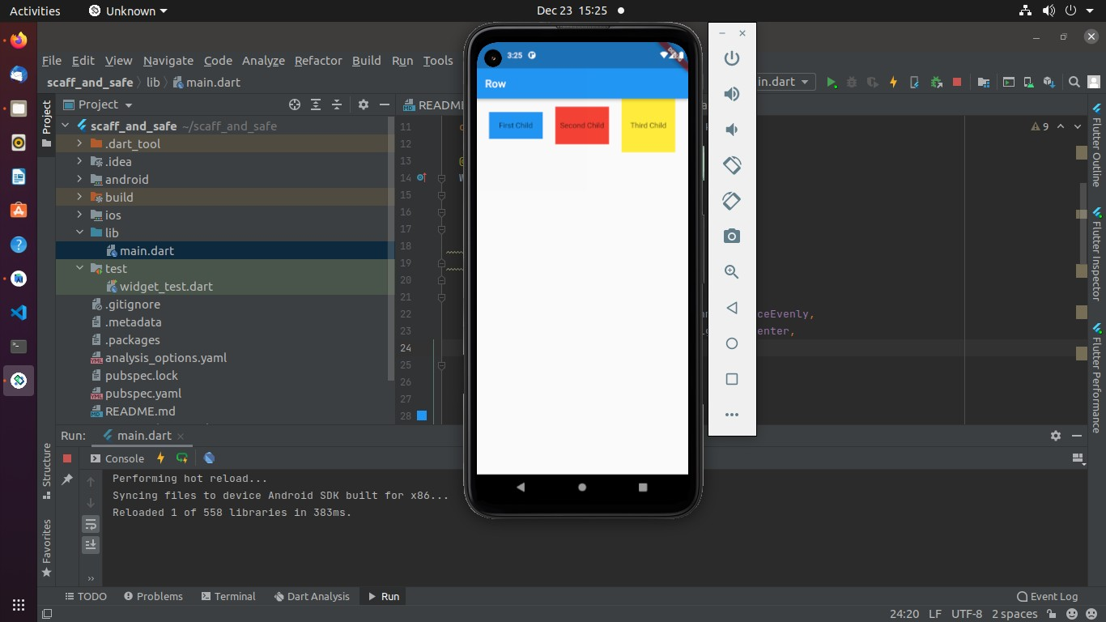

body: Row(

mainAxisAlignment: MainAxisAlignment.spaceEvenly,

crossAxisAlignment: CrossAxisAlignment.end,

children: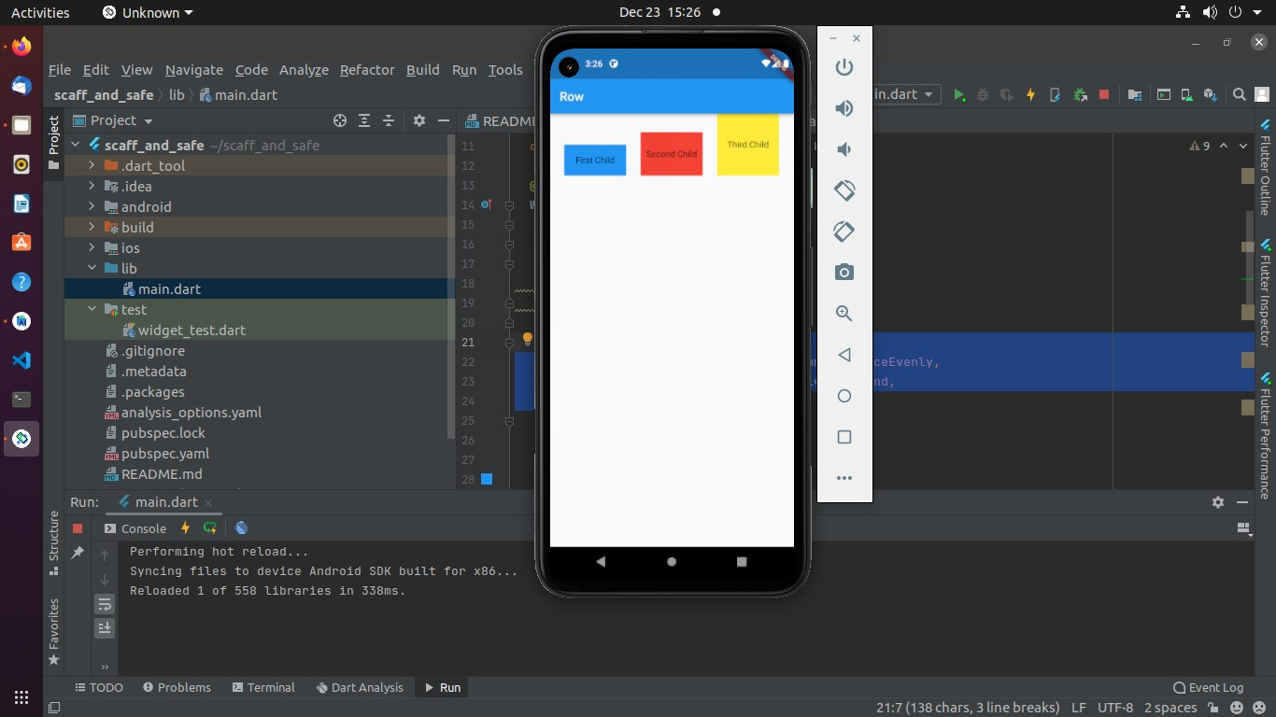

import 'package:flutter/material.dart'; void main() {

runApp(MaterialApp(

home: ColApp(

),

),

);

}

class ColApp extends StatelessWidget {

const ColApp({Key? key}) : super(key: key);

@override

Widget build(BuildContext context) {

return Scaffold(

appBar: AppBar(

title: Text(

"Column"

),

),

body: Column(

mainAxisAlignment: MainAxisAlignment.spaceEvenly,

crossAxisAlignment: CrossAxisAlignment.start,

children: [

Container(

height: 100,

width: 100,

child: Text( 'First Child'),

),

),

child: Center(

color: Colors.*blue*,

height: 100,

width: 100,

color: Colors.*red*,

Container(

child: Center( child: Text(

'Second Child'),

),

),

height: 100,

width: 100,

color: Colors.*yellow*,

Container(

child: Center( child: Text(

'Third Child'),

),

)],

),

);

}

}

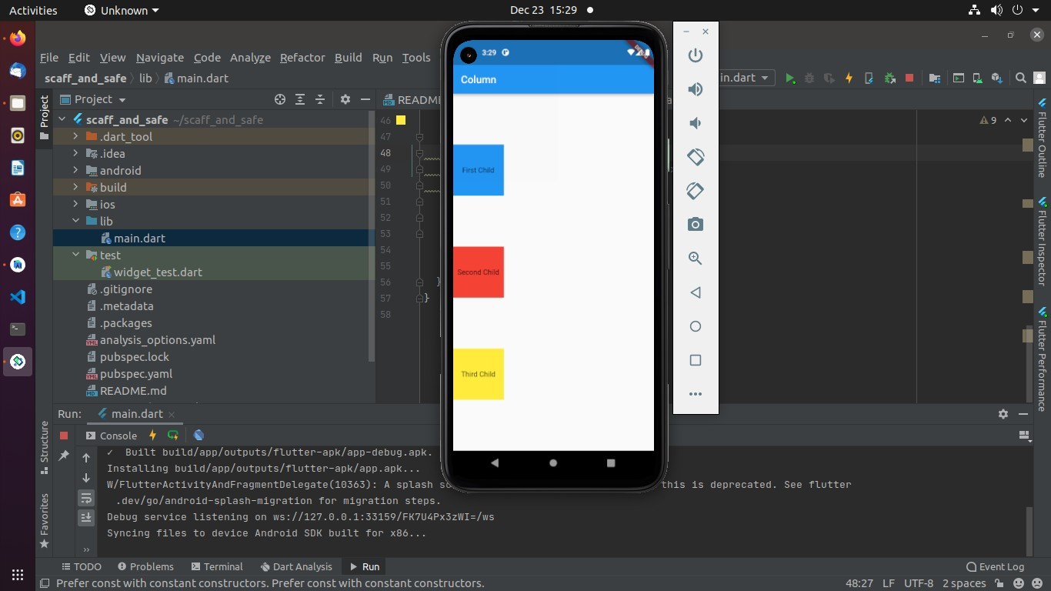

import 'package:flutter/material.dart';

void main() {

runApp(MaterialApp (

home: RowApp(),

),

);

}

class RowApp extends StatelessWidget {

const RowApp({Key? key}) : super(key: key);

@override

Widget build(BuildContext context) {

return Scaffold(

appBar: AppBar(

title:Text('Row/Col'),

),

body:

Row(

mainAxisAlignment: MainAxisAlignment.spaceBetween,

children:[

Column(

mainAxisAlignment: MainAxisAlignment.start,

children:[

Container(

height: 100,

width: 100,

color:Colors.*green*,

children:[

height: 100,

width: 100,

Container(

mainAxisAlignment: MainAxisAlignment.center,

Column(

child: Text(

'first container',

style:TextStyle( color: Colors.*white*,

),

),

),

) ,

],

child: Text(

'first container',

color:Colors.*blue*,

style:TextStyle( color: Colors.*white*,

),

),

),

],

) ,

Column(

mainAxisAlignment: MainAxisAlignment.end,

children:[

height: 100,

width: 100,

Container(

child: Text(

'first container',

color:Colors.*red*,

style:TextStyle( color: Colors.*white*,

),

),

),

],

) ,

],

),

);

}

}

